Visual Morse: A Test of a New Paradigm for Training Morse Code
Denis Anson, MS, OTR, Linda Frame, OTS, Jenny Hopkins, OTS, Lisa Kulmane, OTS, and Pat Streff, OTS

Abstract
Visual Morse is a new approach to display and training Morse code. In Visual Morse, a display of characters is presented, with each character showing the color of the appropriate switch to operate to generate that character. With each switch closure, the display is updated. This study tested the usefulness of Visual Morse for novices to learn Morse code. Forty individuals used either Darci USB or Visual Morse to type for 10 sessions. Results indicated that the more traditional cue sheet is more effective for this population.

Keywords
Computer Access, Morse Code, Training, Alternative Access, Software

Background
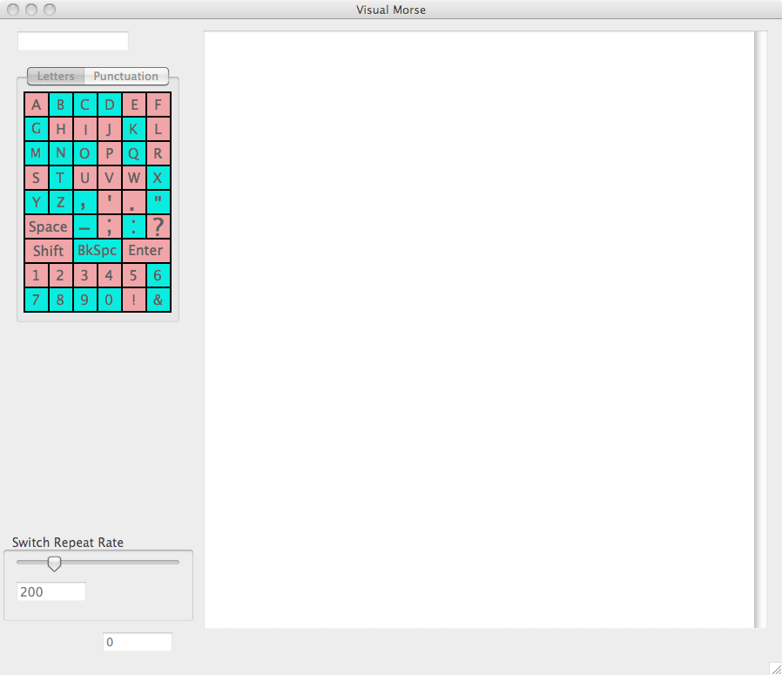
Access to computers and the Internet has moved from a hobby or job for the few to an essential to participation in modern life. In 2001, 72% of all jobs involved computer use [1]. In 2003, 83% of K-12 students were using computers in the classroom, with 92% of students aged 15-17 reporting computer use [2]. By May of 2005, 66% of homes were estimated to have home broadband access [3]. Increasingly, business and government services are preferentially or exclusively provided via electronic interaction. In order to fully participate in modern society, an individual with a disability must have computer access.
Conventional computer input is designed for individuals with two fully functional hands, high visual acuity, and normal hearing [4-10]. For many people with disabilities, such ability is not available, and an alternative access method is required. The choice of access method is dictated in part by the desire of the individual, but is restricted by the physical and cognitive skills of the individual.
For those people with disabilities that severely limit head and arm movement, one potential means of access is Morse code [11-16]. Morse code is one of the few access methods that can be come completely transparent to the user. Long-term Morse users often comment that they no longer no the codes. They think letters and words, and the words appear. In addition, Morse is one of the fastest available alternative access methods. Long term users often type in excess of 30 words per minute, and can exceed the speed of modern text messagers [17].
In spite of the recognized advantages of Morse code as an input method, it is not often considered in clinical practice. Many therapists report that they simply do not consider Morse, are unaware of it as an alternative. One reason for this reticence may be that the therapists do not know Morse, and are reluctant to recommend an access method that they cannot demonstrate effectively. If a means could be found to make learning Morse simpler, it might be used more often.
This study explored the use of a new paradigm for Morse training: Visual Morse. In Visual Morse, the available symbol set is displayed, much like the common cuing sheet often used for Morse training. But rather than showing the series of “dits” and “dahs” of the code, each letter is displayed in the color of the switch that begins the sequence. When a switch is pressed, the colors change to show the next switch activation, that the letter has been composed, or that the letter is not reachable by the sequence that has been pressed.
This study tests the utility of this approach for two switch Morse code, comparing learning with the more common cuing sheet.

Methodology

Subjects
Forty subjects with ages ranging from 18 to 46 (mean age = 23.8) were recruited for this quasi-experimental study. The 33 female and 7 male subjects were able to sit unsupported for at least 20 minutes, read 12 point Times Roman print, hear well enough to respond to spoken instructions, and to press AbleNet Jellybean switches. None of the subjects had significant skills in Morse code at the beginning of the study.

Procedure
The subjects were randomly assigned to learn Morse code using either a prototype Visual Morse application or Darci Morse (Westest Engineering) and the traditional cue sheet. To control for possible effects of the responsiveness of the text input program, all text was typed into the Visual Morse prototype.
Subjects were seated before Apple iMac computers with 24 inch displays, 3.06 GHz Intel Core Duo processors, 4 GB RAM, and 500 GB hard drives. The sample text to be typed was placed to the left of the screen on a document holder, and the JellyBean Switches were placed in front of the screen. Subjects were allowed to adjust their seat height as well as the position of the source document and switches to their comfort.
Each subject was asked to reproduce 10 successive segments from Mark Twain’s Life on the Mississippi [18]. The subjects were asked to type for 20 minute intervals, and received a new segment for each trial.

Data Analysis
The number of words typed and accuracy were recorded for each trial. Accuracy was determined by comparing the typed text with the source text using Microsoft Word’s “Compare Documents” feature. Each block of text identified as “different” was counted as a single error, regardless of the number of changes within it.
Because of the variability of typing speeds between trials, the average of the first two trials and the last two trails were compared between the two groups to determine the relative effectiveness of the training method.
The initial typing speed for the experimental group was 1.6 wpm, compared with 2.9 wpm for the control group. After 10 practice sessions, the experimental group was typing at 2.7 wpm, compared with 4.04 for the control group. While both groups had accuracy in excess of 90%, the control group was significantly more accurate both initially and at the end of the study.

Results
The results of this study do not support the use of Visual Morse for training two-switch Morse code. This finding agrees with the assertions of the Koch and Farnsworth methods of training Morse code for Ham Radio operators, where it is believed that codes for each letter should be learned as units or “tunes.” The visual display of a cue sheet allows the learner to perceive the entire code at once, facilitating this “unit” learning. Visual Morse, on the other hand, breaks code into elements, and does not support “unit” learning of the code for letters.
A secondary finding of the study is based on the examination of changes from session to session. In order to control for possible fatigue effects, subjects were allowed no more than three trials in any 24-hour period. Because of scheduling restrictions, many subjects had a week or more between sessions. The data from these subjects shows substantial regression between sessions, suggesting that consistent and frequent training is needed to effectively learn Morse code, at least in the early stages.
Figure 1. The Visual Morse Prototype

Discussion
Among able-bodied Morse users, code can be produced with a single switch, with a short closure being interpreted as a “dit” and a longer closure being interpreted as a “dah,” or with two switches, where one is “dit” and the second is “dah.” For individuals with disabilities, one-switch and two-switch Morse are the most common approaches, with two-switch Morse being preferred when possible since it allows faster typing.
However, for individuals with motor control issues that do not allow for timed movements, Morse has been extended to include a three-switch variant. In three-switch Morse, one switch indicates “dit,” the second indicates “dah,” and the third indicates the completion of a letter. Individuals for whom three switch Morse code is appropriate cannot produce “tunes,” as they are typically experience variable motor delay in their movement. Traditional training in Morse may be inappropriate for such individuals, and Visual Morse might be more appropriate, not only for initial training, but for long term use.
At this point, the concept of Visual Morse can be considered a solution in search of a problem. Three-switch Morse may well be the appropriate “problem” for this innovative approach to Morse cuing.

Bibliography
- US Census Bureau. Computer and Internet Use in the United States: September 2001. [Online] 2001 [cited 2005 April 17]; Census Data on Computer Use]. Available from: http://www.census.gov/population/www/socdemo/computer/ppl-175.html.
- US Census Bureau. Computer and Internet Use in the United States: 2003. [Online] 2005 [cited 2006 Feb. 2]; Available from: http://www.census.gov/prod/2005pubs/p23-208.pdf.
- infoplease.com. Boardband at Home. [On-line] 2009 [cited 2009 July 2]; Available from: http://www.infoplease.com/ipa/A0931240.html.
- Aaronson, D. and P. Gabias, Computer use by the visually impaired. Behavioral Research Methods, Instruments, and Computers, 1987. 19: p. 275-282.
- Bristo, M. Access to Multimedia Technology by People with Sensory Disabilities. 1998 [cited 2005 April 25]; Available from: http://www.ncd.gov/newsroom/publications/1998/sensory.htm#3
- Brown, C., Assistive Technology Computers and Persons with Disabilities. Communications of the ACM, 1992. 35(5): p. 36-44.
- Cooper, R.J., Assistive technology 101, in Exceptional parent. 2000. p. 71-73.
- Glinert, E. and B. York, Computers and People with Disabilities. Communications of the ACM, 1992. 35(5): p. 32-35.
- Goodman, G., D. Tiene, and P. Luft, Adoption of assistive technology for computer access among college students with disabilities. Disability and Rehabilitation, 2002. 24(1): p. 80-92.
- National Center on Accessible Information Technology in Education. What is assistive technology? [Online] 2002 [cited 2004 July 29]; Available from: http://www.washington.edu/accessit/articles?109
- Anson, D., et al. Long-term Speed and Accuracy of Morse code vs. Head-pointer Interface for Text Generation. in RESNA 2004 Annual Conference. 2004. Orlando, FL: RESNA Press.
- Clement, M., Morse code method of communication for the severely handicapped cerebral palsied child. Cerebral Palsy Review, 1961. September-October: p. 15-16.
- Federwisch, A. Computer becomes therapy, link to world for patient 1995 [cited 2009 July 6]; Available from: http://www.makoa.org/jlubin/ahfeat4.htm.
- Jarus, T., Learing Morse code in rehabilitation: Visual, auditory, or combined method? British Journal of Occupational Therapy, 1994. 57: p. 127-130.
- Lubin, J. Morse codes for Computer Access. 2009 [cited 2009 July 6]; Morse code is perfect for someone with little or no ablility to move. A person just needs to be able to activate a switch. ]. Available from: http://www.makoa.org/jlubin/morsecode.htm.
- McDonald, J.B., et al., Advantages of Morse code as a computer input for school aged children with physical disabilities., in Computers and the Handicapped. 1982, National Research Council of Canada: Ottawa.
- Henderson, M. A race to the wire as old hand at Morse code beats txt msgrs. The TimesOnline 2005 [cited 2009 Sept. 23]; Available from: http://www.timesonline.co.uk/tol/news/uk/article381748.ece.
- Twain, M. Life on the Mississippi. 1883 [cited 2006 June 15]; Available from: http://www.gutenberg.org/files/245/245.txt.

